OA Twelve Step Workshop
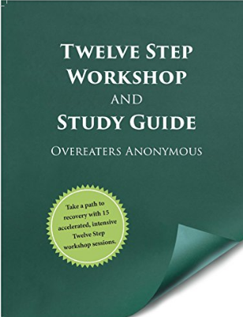
A telephone meeting using the book Twelve Step Workshop and Study Guide

2nd and 4th Thursdays of each month, 8:00pm – 9:00pm Mountain Time on the phone
Beginning January 23, 2020
Take a path to recovery with 30 intensive 12-step sessions.
Leslie 720 685 8104 (no text), flowerlover85282@gmail.com
To foster trust and sharing, this meeting will close after the 2nd session.

